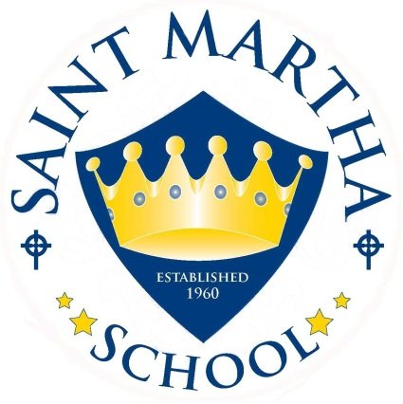

2019-2020 School Year
Welcome To Transitional Kinder (TK)
Here are a few things we want parents to know
*Classroom Discipline Plan/Rules
*Student Expectations
*Curriculum
*Homework Folder
*Book Orders
*Take Home Activities

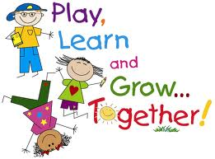

Classroom Discipline Plan/Rules

Classroom Rules:
- I will raise my hand to speak
- I will follow directions quickly
- I will keep my hands and feet to myself
- I will use my inside voice
- I will make smart choices

Student Expectations
*Respect others
*Listen and follow directions
*Take turns and share
*Raise hand before speaking out in large group
*Put away materials
*Talk out problems by using our words
*Follow inside and outside safety guidelines

Reinforcement of Behavior/Rewards
*Class goals
*Class points/incentives

Consequence Steps
- We give students a reminder
- Give students a short time out to think about behavior
- We notify parents if time-outs are occurring regularly
- If misbehavior continues, conference with parents to make individual behavior plan
- If defined steps have been exhausted, we have parent-principal-teacher conference, if need be
Curriculum
Religion
We will do religion daily, using the provided books, Sadlier-We Believe. Children will also practice daily prayers-Sign of the Cross, Prayer before meals, etc.

Language Arts-Wonders Program
*Phonics
*Daily Message
*Word Wall
*Phonemic Awareness
*Teacher Read Alouds
*Letter of the Week

Math-Number Sense
*Recognize numbers 0-10 and beyond!
*Count by 1’s
*Sort, identify, and describe objects by attributes (shape, color, size)
*Identify and name shapes
*Daily calendar
*Describe simple patterns (AB, AAB, ABB)

Social Studies
*Character Education (responsibility, fairness, citizenship, etc.)
*Jobs in the Community
*Parts of the Calendar
*The Four Seasons
Science
*The Five Senses
*Plants
*Animals
*Oceans

Art & Music
Every day we incorporate art and music in lesson plans.
*Small groups with art
*Poems and songs daily
*Music and Movement

Homework Packet
Homework will be sent out Monday to be returned on Friday.
It may include math and phonics sheets, practice a poem they have learned, practice writing their name and coloring activities.

Take Home Activities
-Monthly Family Projects
-Our class mascot

Superhero of the Week
Each Friday, a student is named superhero of the week. They will fill out Super Student poster to share with us. They will also assist as “special helper” to the class. Super student is picked randomly and not done as a reward for behavior.

Scholastic Book Orders
Every month a book order will be sent home. The savings are often more than 50%, so check them out! Another benefit in ordering from book clubs, the teacher receives bonus points with every student purchase! I can use them to build classroom library for students. Along with order form, you will receive our classroom code for convenient online ordering from home.

Learning Centers
What are they developing at centers?

Art
Develops fine motor skills and eye/hand coordination
Stimulates imagination, creativity, and self-expression
Promotes decision making and planning skills in regards to design
Reinforces knowledge of shape, color, space, size, and patterning
Provides the opportunities to practice proper use of pencil, paintbrush, and scissors

Computers
Provides opportunities to practice following directions
Boosts print awareness
Promotes responsibility
Enhances fine motor skills and eye/hand coordination

Library
Reinforces the importance of print in communication, fostering a love of reading and a respect for books
Encourages self-expression and imagination
Builds letter and word recognition skills as well as vocabulary
Boosts ability to sequence pictures and events
Improves ability to interpret pictures in a story
Supports understanding of print concepts and the parts of a book

Puzzles & Manipulatives
Enhances problem-solving, sequencing, patterning, and sorting skills
Encourages an understanding of one to one correspondence
Reinforces concepts of number, shape, size, color, texture, and location

Writing
Enhances fine motor skills and eye/hand coordination
Boosts imagination, self-expression, and understanding the purpose of writing
Strengthens communication, vocabulary, spelling, and phonemic-awareness skills

These are just a few of the things going on throughout the year in TK. Together I hope this will be a successful year for children and families!

